Newsletter
Issue 4

29 September 2023

Dear Parents and Carers

It has been another busy week in school – the children are settling in well to the new term and our new Year R children are quickly getting into their school routine.

We have our Parents Evenings coming up on Wednesday 11 and Thursday 12 October for Years R,1,2,3,4 and 6. Parents Evenings for Year 5 will be taking place on Tuesday 10 and Wednesday 11 October due to Miss Langridge running the football training on Thursday.

Sign- up sheets will be available in the hall from Tuesday 3 October at the start and end of the school day. If you are not able to get in to school to sign up please telephone or email the school office and one of our admin team will be happy to make the appointment for you.

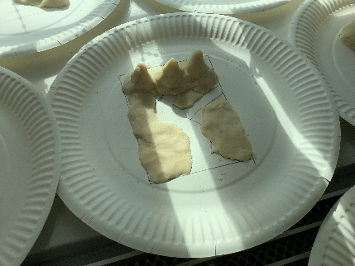
Year 4 have had a busy week - on Tuesday some students from St Swithun’s school came into school to teach them how to play lacrosse and today they have been making salt dough rivers.

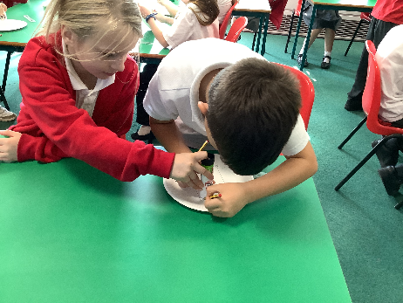
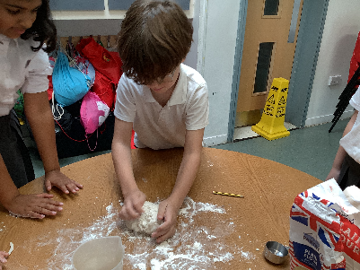

Looking ahead we have, once again be fortunate to secure discount prices to be able to take the whole school (not the Nursery Class) to the Pantomime in December. The Pantomime this year is Cinderella and we will be going to the 10am performance on Thursday 14 December. This will be a lovely end of term treat for the children. A separate letter has been sent out this week.

Change of Menu
There will be a change of Menu next week on both Thursday 5 and Friday 6 October. Thursday is Census Day and it would be helpful to the school if as many children as possible could have a school lunch that day, as part of our funding is based on school meal take-up. The menus will be as follows:
Thursday 5 October
Red Menu: Fish and Chips
Green Menu: Tomato Pasta

Friday 6 October
Red Menu: Chicken Katsu Curry
Green Menu: Cheese and Tomato Quesadilla

Year R School Applications
If your child is four, or will turn four before 1 September 2024, they can start school in September 2024. For more information go to www.hants.gov.uk/admissions Applications are open from 1 November 2023 and will close on Monday 15 January 2024.

Secondary School Applications
Secondary School place applications for September 2024 are now open and will close on Tuesday 31 October 2023. Parents and Carers with children due to move to secondary school next year can now apply for their child’s school place. Applications can be submitted online or paper forms can be requested by emailing admissions.team@hants.gov.uk.

Halloween Disco
Date for your diary – the PTA have organised a Halloween Disco, taking place on Thursday 19 October. KS1 and Nursery from 5pm – 6pm and KS2 from 6.30pm – 7.30pm. Prizes for best homemade costumes. The cost is £3.00 per entry which includes drinks, sweets and games. Please note Parent/Carers must stay with Nursery Children.

Learning Behaviours
We have held this week’s Learning Behaviours assembly. This is where each teacher chooses a child/children that has demonstrated the chosen learning behaviour of the week. The teacher shares with everyone what the child has done and then we all celebrate their achievement. This term we are looking at respect. The children who were chosen this week were:

Year One Alfie B

Year Two Clara M

Year Three Grace S

Year Four Joshua P

Year Five Skyler V

Year Six Rían G-P

School Lunches
Thank you to everyone for settling their lunch accounts, however the lunch debts are now at an all-time high - please could you ensure that your account is kept up to date. For your information the money owed per class is as follows:-

Hares £ 218.33
Foxes £ 67.95
Herons £ 282.20
Kingfishers £ 321.60
Nursery £ 81.00

From Monday 18 September your child will not be able to order a school lunch if the debt is above £10.00 – if the debt is over £10.00 they will need to bring in a packed lunch. Please can you arrange to clear your Lunch accounts before next week.

If you would like an up to date statement of your child’s account please contact the Admin Team. If you have not yet registered to pay online via Scopay and would like a copy of your login details please email us and we will be happy to help. We would appreciate it if all accounts, including any outstanding Breakfast Club and After School Club accounts, could be settled as soon as possible. Please ensure that your After School Club Account is up to date as we employ extra staff for this club. If you would like an up to date statement please contact the school office.

Thank you for your continued support.

Yours faithfully

Mrs Bordoli
Interim Headteacher

Dates for your diary (new dates in red)
Open Morning (9.30am) 19 October 2023
Halloween Disco 19 October 2023
Inset Day 20 October 2023
Open Morning (9.30am) 29 November 2023
Whole School Trip to Cinderella 14 December 2023
School breaks up for Christmas 15 December 2023
School returns for Spring term 2 January 2024
Open Morning (9.30am) 5 January 2023
Inset Day 19 February 2024
Inset Day 28 June 2024
Inset Day 1 July 2024

